Practical - 3

Aim: -
Build a network that connects a head office with a branch office and observe how information flows between them in different directions. Track each step of the communication to understand how the network handles the exchange.

Theory: -

When connecting a head office and a branch office, a WAN (Wide Area Network) is used to link the two LANs. Routers at each location forward data between networks, while switches manage internal device communication. Technologies such as VPN tunnels, MPLS, or leased lines provide secure connectivity.
Information flow is bidirectional:
- From Head Office → Branch Office, data passes through the head office LAN → router → WAN link → branch office router → LAN.

- From Branch Office → Head Office, the process is reversed.
Tracking communication involves checking each step (IP addressing, routing, packet forwarding, and firewall/security checks) to see how
the network ensures reliable data exchange.

Output: -
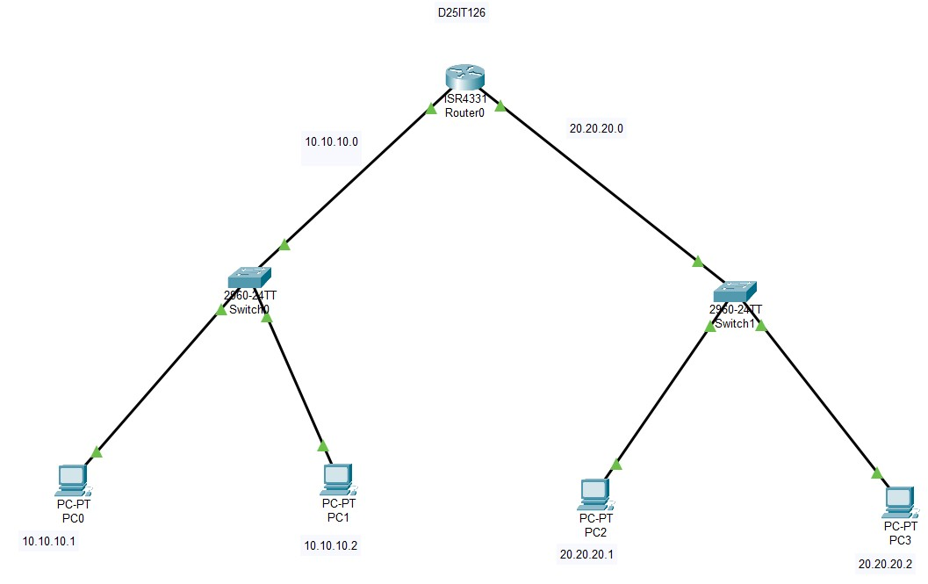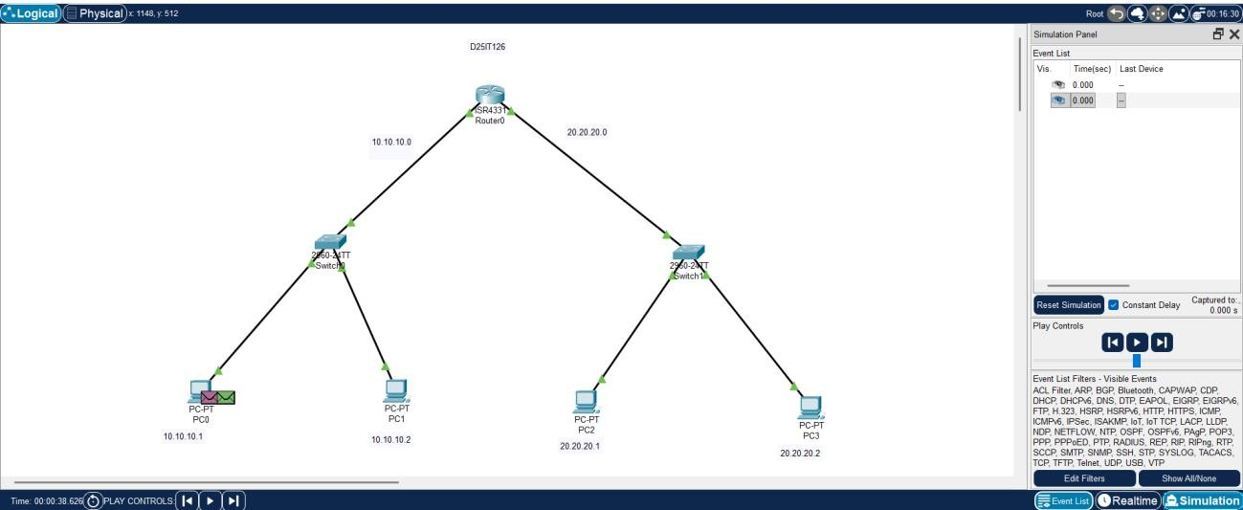

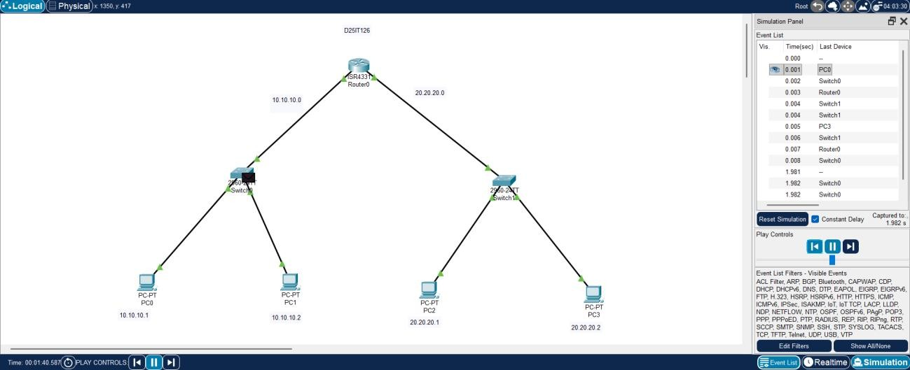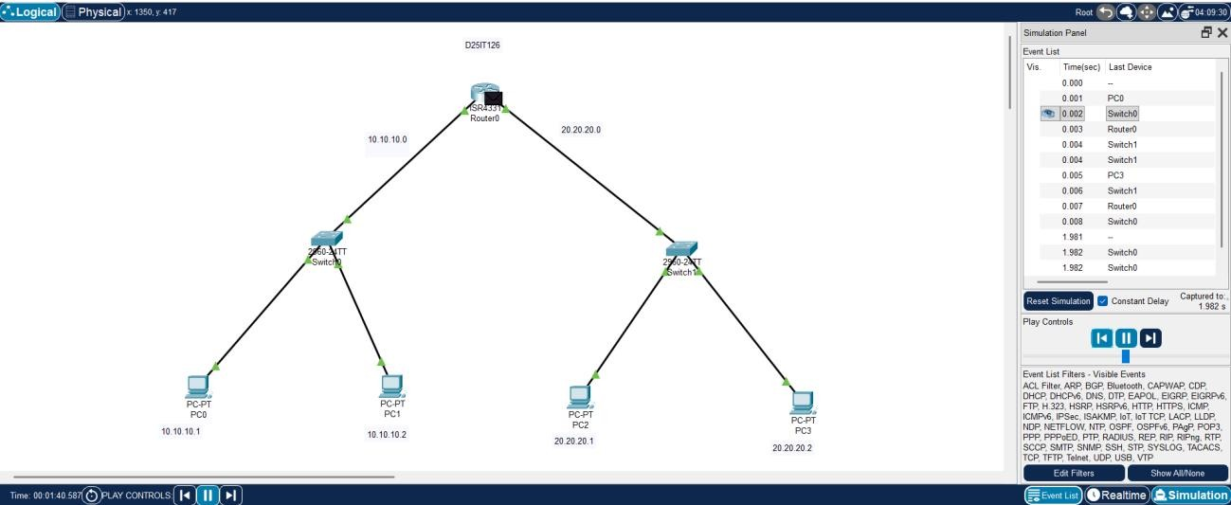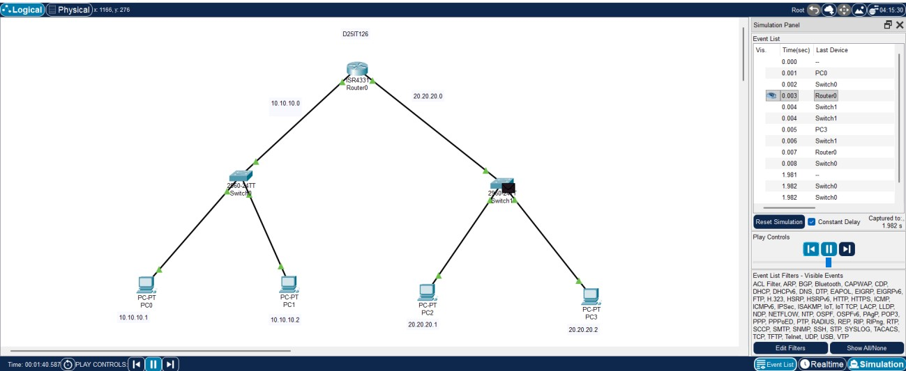
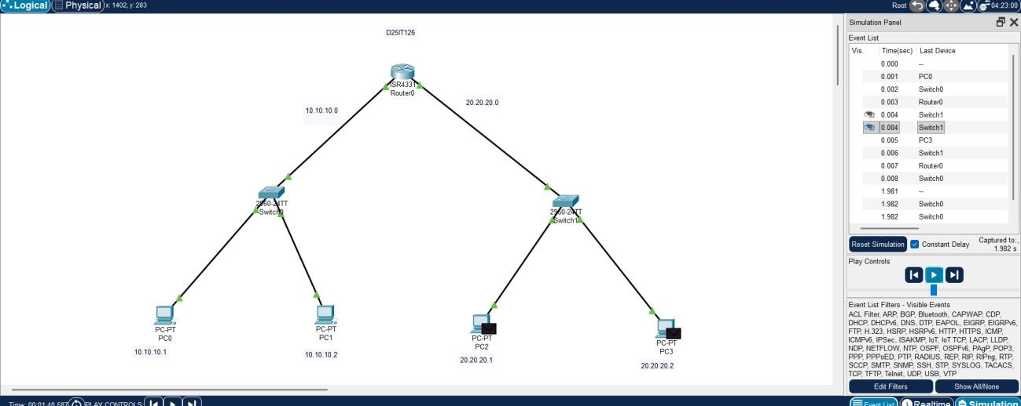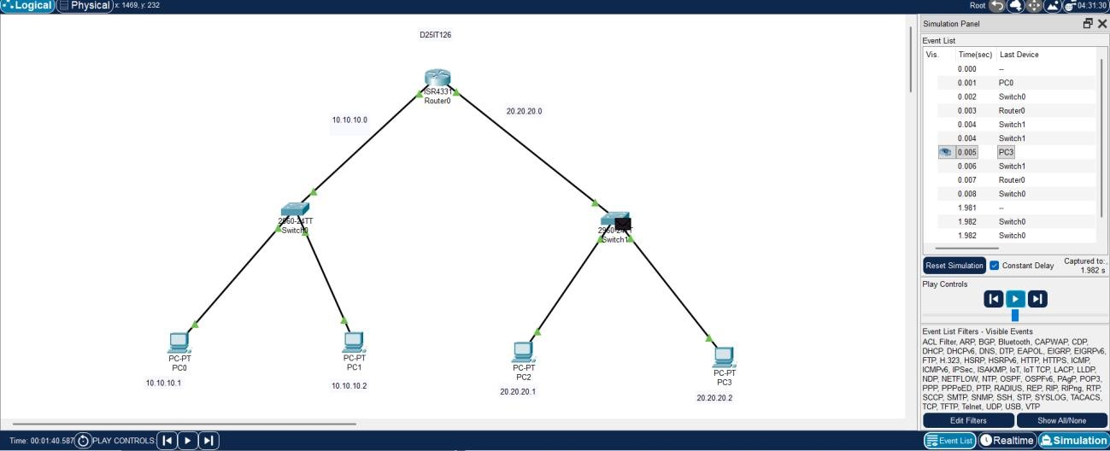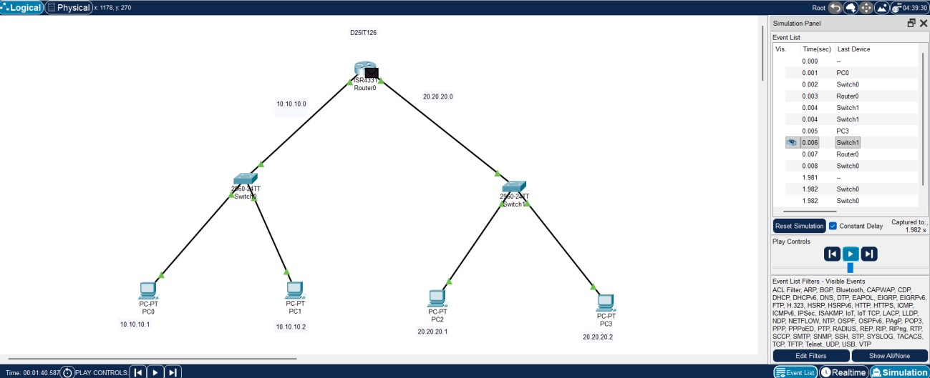
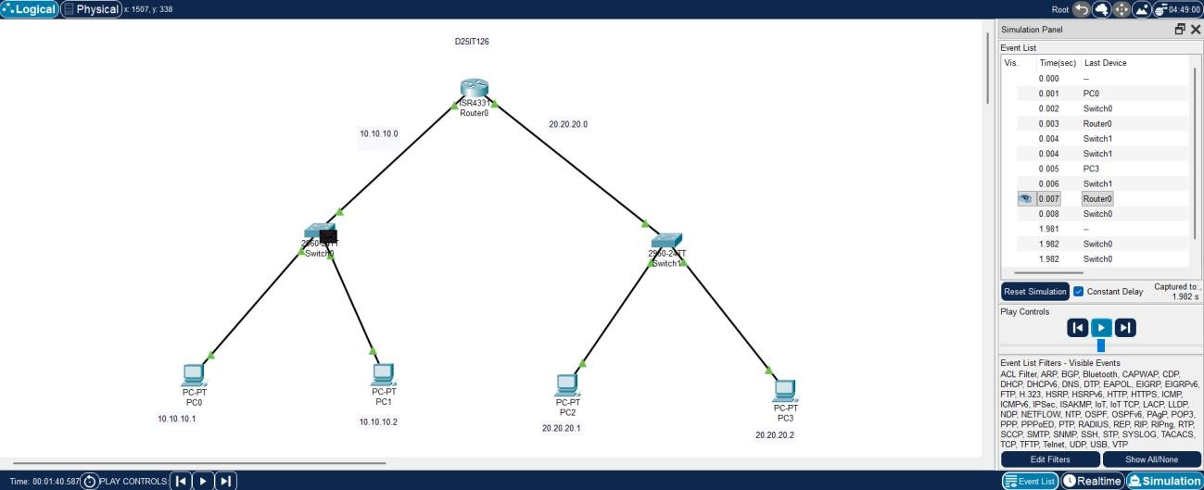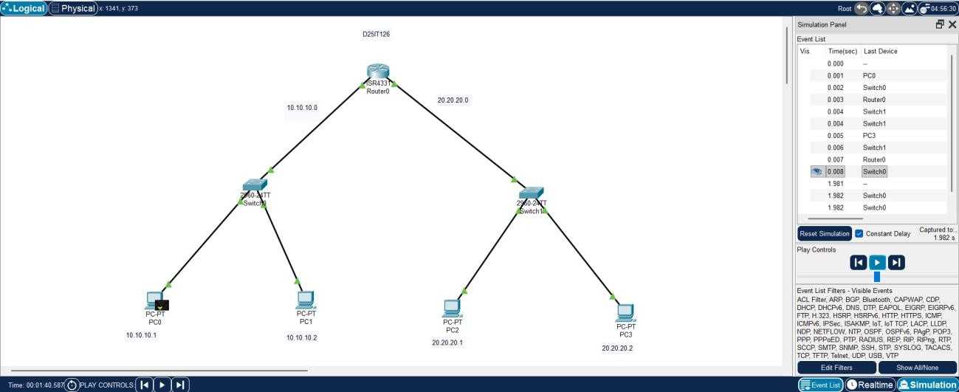

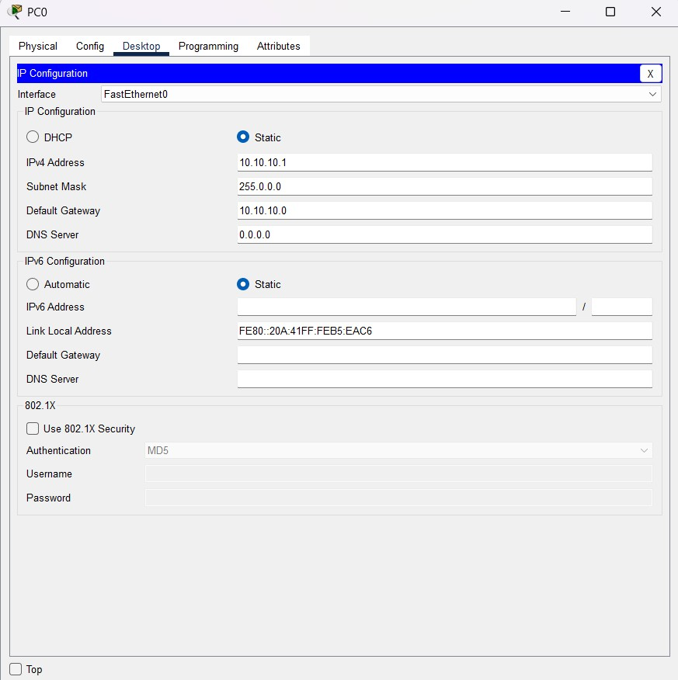

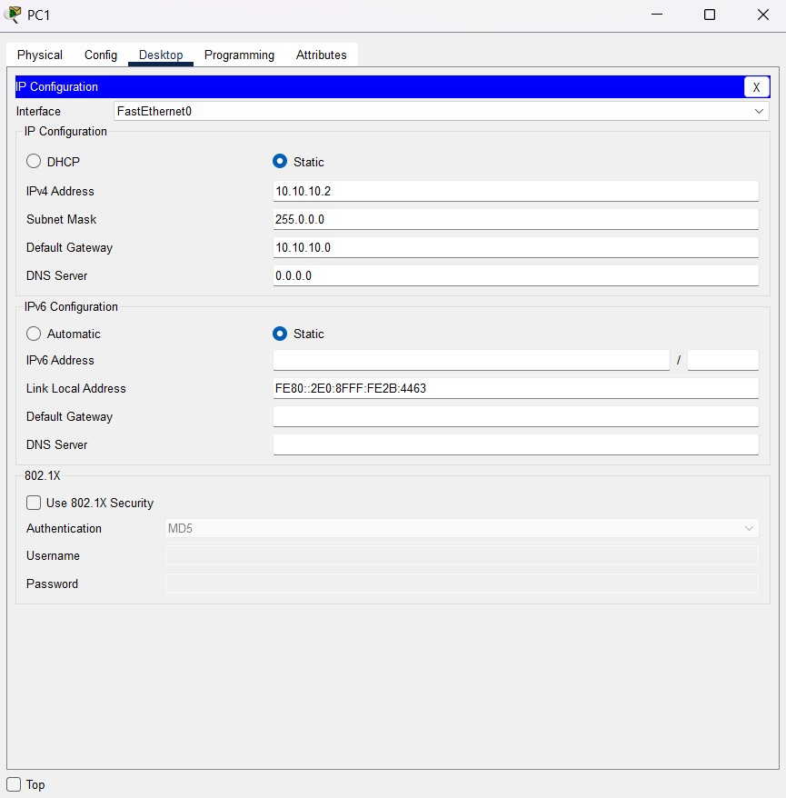

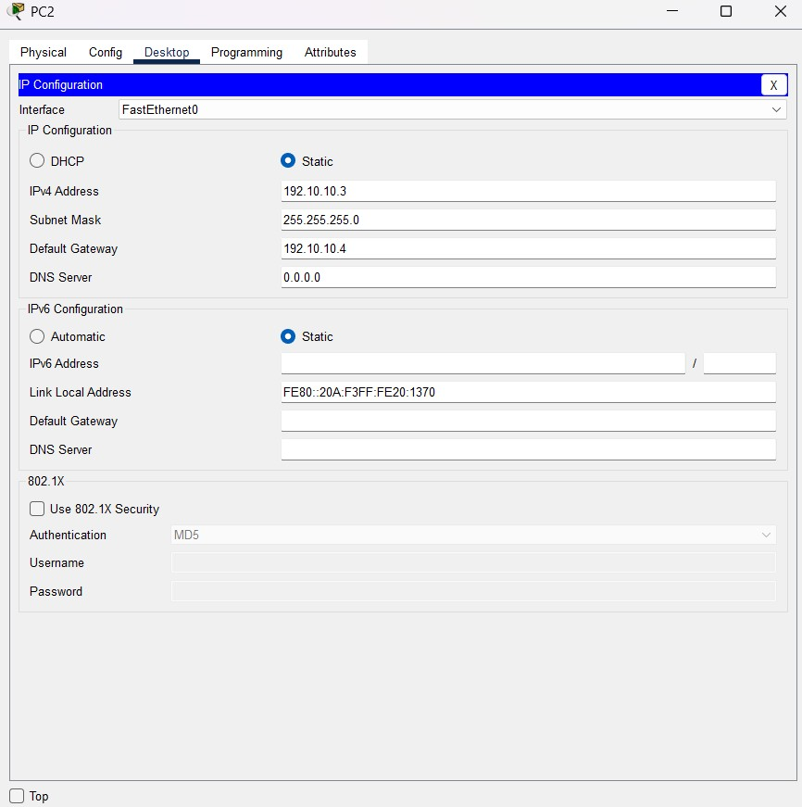

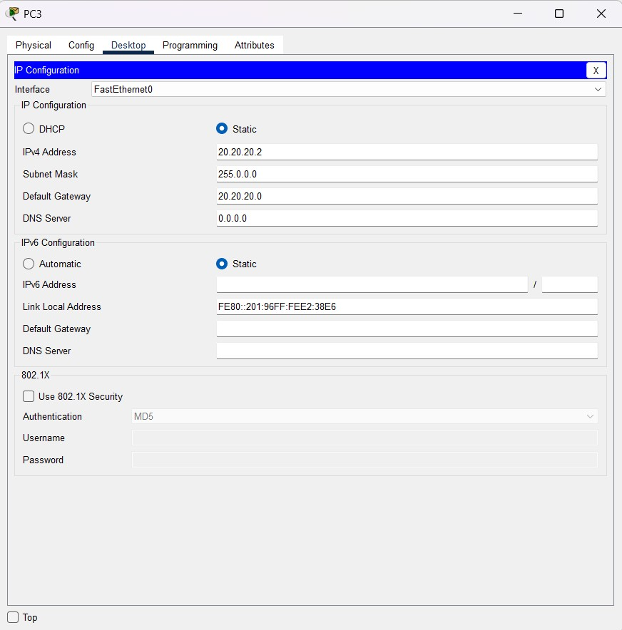

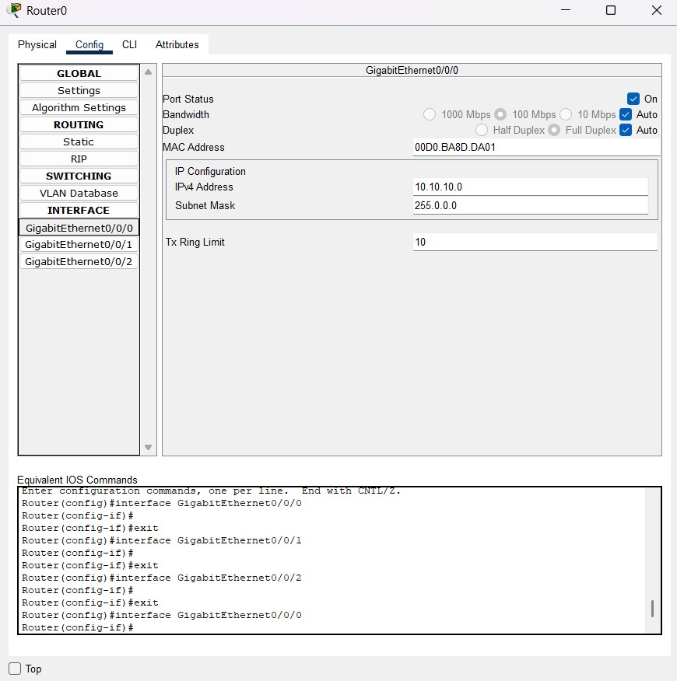

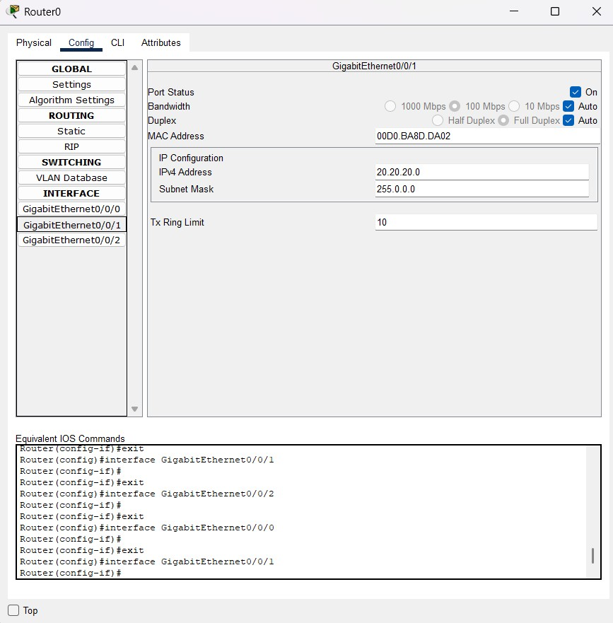

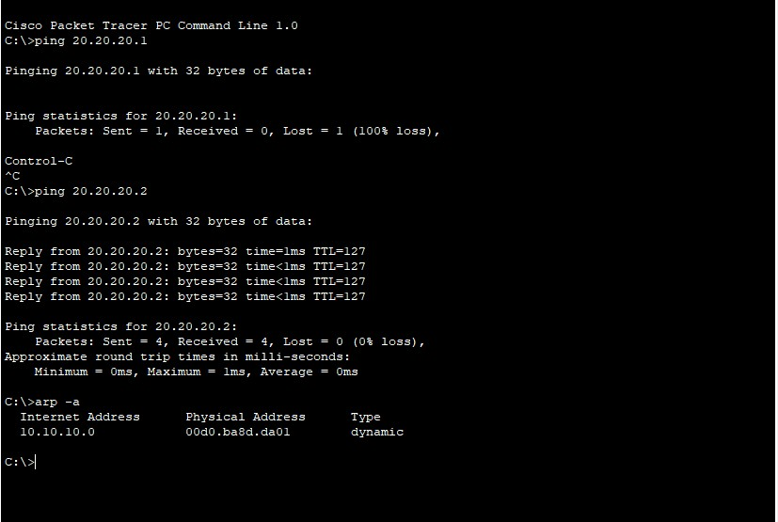

Conclusion : -
A properly designed WAN enables smooth two-way communication between head and branch offices. By observing the step-by-step packet journey, we understand how routing, switching, and WAN technologies cooperate to ensure secure and efficient information flow.

Q & A: -
Q1. Which type of network connects a head office and branch office in different locations?
A: A Wide Area Network (WAN).
Q2. What devices are essential at each office for inter-office communication?
A: Routers (for WAN connectivity) and switches (for LAN management).
Q3. How does data travel from the head office to the branch office? A: Head Office LAN → Router → WAN → Branch Office Router → Branch LAN.
Q4. What ensures data knows the correct path between offices? A: Routing tables and protocols (e.g., static routes, OSPF, BGP).

